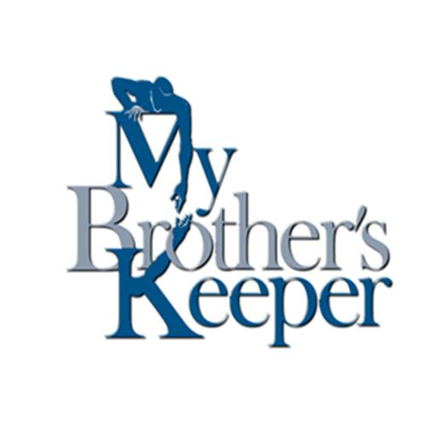I Am My Brother’s Keeper
Ten Week Outline: Motivational Curriculum provided by I am My Brother’s Keeper
1) Responsibility
a) The purpose of teaching responsibility is to instill the values that are needed to resolve crisis when they come.
b) Teaching the ability to respond effectively in the midst of a personal crisis.
c) The principle knowing ones strengths and weaknesses in any situation in life and what will be ones attitude. Attitude determines the approach and the approach determines success or failure.
d) The key is to teach how to think differently, act differently resulting in a change in attitude and a change in behavior.

2) Vision
a) The purpose of seeing how one view their future helps to change the view of the future from negative to positive and then become motivated to make progress.
b) Teaching the importance of having a dream, a desire to do something in life.
c) Seeing how a person views the future. Either positively or negatively determines how one approaches the future.
d) The principle of having a vision is to look at the future and determine how you will live in the present.

3) Self Esteem
a) The purpose of this teaching is to raise self-image from low to high. Then the attitude will change from timidity to confidence.
b) Teaching how to view ones self (does one think positive or negative about their self?).
c) The principle is it’s ones Self-Esteem that determines ones destiny.

4) Faith
a) The purpose is to strengthen ones convictions so that they will no longer hinder their personal growth.
b) Help one to be willing to believe in possibilities in ones life and to resist the impossibilities.
c) The principle is what one believes (ones own convictions).
d) The key to faith is perseverance. Having the will to go on when things are so bad that one feels like giving up.

5) Love
a) The purpose is to manage transitioning from a life of personal crisis to a life of self-sufficiency.
i) Learning to love ones self physically. Being committed to keeping ones body free of disease and abuse and full of vigor. The key is to have good hygiene, examination, exercise and diet.
ii) Learning to love ones self mentally. Being committed to keeping ones mind free of tension and full of peace. The key is to stay focused.
iii) Learning to love ones self socially. Keeping ones relationships free of strife and full of harmony. The key is to follow peace.
iv) Learning to love ones self spiritually. Keeping ones soul in God’s will, free of sin and shame and full of integrity. The key is keeping ones life lined up with God’s will and His word.
v) Learning to love ones self economically. Being committed to money management, keeping ones life free of poverty and full of productivity. The key is to increase ones value in the marketplace.
b) Teaching the ability to love ones self. Pursuing self-sufficiency through, physical, mental, social, spiritual, and economics skills.
6) Discipline
a) The purpose of discipline is to strengthen ones determination to pay the price for personal growth.
b) Teaching the determination to give something up to get ahead. Being willing to separate themselves from the things that are detrimental.
c) The key is to make the decision to change, which is followed by the process of change.
d) The principle is being willing to suffer short-term pain in order to make long-term gain. (No pain; no gain)

7) Association
a) The purpose of this is to develop an effective strategy for regulating relationships so that they work for them and not against them.
b) Teaching the ability to manage the different people in ones life.
c) The principle is that the people in ones life can either make them or break them.
d) The key is never to underestimate the power of influence.
8) Planning
a) The purpose is to prioritize ones activities. Making choices to further ones goals.
b) Teaching the ability to manage the events on ones life before hand.
c) The principle of this is: if one fail to plan, one plan to fail.
d) The key is not how much time one has, but what one does with their time.

9) Work
a) The purpose is that working develops three important abilities:
i) Ones ability to prepare for work;
ii) Ones ability to obtain work;
iii) Ones ability to maintain work.
b) Planning and the working go hand in hand. First one plans to work, then one works the plan.
c) The strategy for this is: One must build (career work) and defend (character work) ones house of progress at the same time. One must have a hammer in one hand (build) and a shield (defend) in the other.
d) The principal is that one must work harder on ones self than on anything else because one can be ones own worst enemy.

10) Wealth
a) The purpose is to enhance ones ability to achieve economic self-sufficiency.
b) Wealth develops two important abilities:
i) The ability to maximize ones resources;
ii) The ability to manage ones resources.
c) The key is not what one get; it’s what one does with what one get. It’s not what one earns, it’s what one saves.
d) One must have a budget, which is a financial plan with two parts, income and expenses. If ones expenses exceed ones income, ones upkeep will be ones downfall.

Our lessons will be those of demonstrations through drama skits, testimonials, group discussions and quizzes using the Holistic Hardware Tools. As the program progresses we will have various speakers to come do in-house presentations. (Ex. Job Fair, Beauticians, Cosmetologist) We help people to get GED’s, Driver’s license, prepare résumé’s, train on how to interview and work on work ethics. We teach computer classes from basic to advance. Our mission is to help men to see their own self worth and become employable citizens. I Am My Brother’s Keeper will contribute 18 hours per week to help men achieve their set goals in 6 month intervals.

